Finals Lab Task 6. Connection Mysql using Python using CLI
- Make sure you have installed the following pre-requisites before proceeding:
  - Mysql-connector
  - Mysql-connector-python
  - Xampp is running along with Apache and Mysql in the background
  - Make sure you have a database in Mysql named employeeDB with an tbl_employee_info table with at-least 5 records

- Guided by the Demo code attached in this task. Test_DemoDB.py
- Kindly continue working on the code that will allow the user to navigate through the
Database and perform CRUD operations. Follow the following CLI Menu Options:
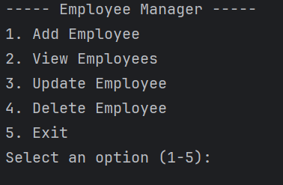

- The user should be able to add New Records when 1 is selected and show the records, 2- Display all records, 3 Update a Record and show the updates, 4 – Delete a record 5- Exit

TestDb_Demo.py
import mysql.connector
# Connect to the SQLite database (it will create the DB file if not exists)
conn= mysql.connector.connect(
host="localhost", # Replace with your MySQL host (e.g., IP address or hostname)
user="root", # Replace with your MySQL username
password="", # Replace with your MySQL password
database="testdb" # Replace with the name of your database
cursor = conn.cursor()
#Insert a New Record
def add_employee():
name = input("Enter name: ")
emp_id = input("Enter employee ID: ")
salary = float(input("Enter salary: "))
cursor.execute("INSERT INTO employees (name, emp_id, salary) VALUES(%s,%s,%s)", (name, emp_id, salary))
conn.commit()
print("Employee added successfully!\n")
view_employees()
# View all employees
def view_employees():
cursor.execute("SELECT * FROM employees")
rows = cursor.fetchall()
if rows:
print("\nEmployees List:")
for row in rows:
print(row)
else:
print("\nNo employees found.")
# Update employee
def update_employee():
emp_id = input("Enter employee ID to update: ")
name = input("Enter new name: ")
salary = float(input("Enter new salary: "))
cursor.execute("UPDATE employees SET name=%s, salary=%s WHERE emp_id=%s", (name, salary, emp_id))
conn.commit()
print("Employee updated successfully!\n")
# Delete employee
def delete_employee():
emp_id = input("Enter employee ID to delete: ")
cursor.execute("DELETE FROM employees WHERE emp_id=%s", (emp_id,))
conn.commit()
print("Employee deleted successfully!\n")
#Test the methods
if __name__ == '__main__':
# add_employee()
# update_employee()
# delete_employee()
view_employees()

